TOWNSVIEW SCHOOL
2017-2018 SCHOOL SUPPLY LIST: KINDERGARTEN

- 1 package of 24 Crayola pre-sharpened pencil crayons
- 1 package of 24 Crayola crayons
- 2 packages of 8 Crayola markers
- 2 packages of 12 HB pencils
- 3 white erasers with white plastic covers ( i.e Basic brand or Staedtler brand)
- 2 Elmers Glue Sticks 40g
- 2 Poly duo-tang report covers (plastic) - blue
- 2 Poly duo-tang report covers (plastic) -orange
- 2 Poly duo-tang report covers (plastic) -red
- 2 Hilroy yellow exercise books – ½ plain & ½ ruled, looks like this:
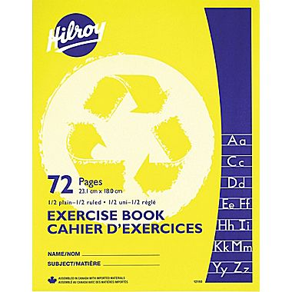
- 2 Expo Dry erase markers, blue
- 1 Fine-tip black Sharpie marker
- 2 boxes of Kleenex
- 1 box of Large Ziploc bags
- 1 package Lysol wipes (80 count)
______________________________________________________________________________

NOTES:
- Townsview School is a scent-free and peanut-free environment.
- Please note that students will need a lunch box, book bag and sneakers with non-marking soles for Phys. Ed and the classroom.
- Townsview School will be offering parents the opportunity to either purchase your child’s school supplies for the 2017-2018 school year yourself, or have the school to purchase on your behalf.
- You can send $45.00 either by cheque (cheques made payable to Townsview School) or you can pay by cash (exact change please) as well, receipts will be provided. If you wish to buy a school pack from the school, it must be purchased by Thursday, June 22, 2017. After this date, parents must purchase school supplies on their own.

